1. New method:

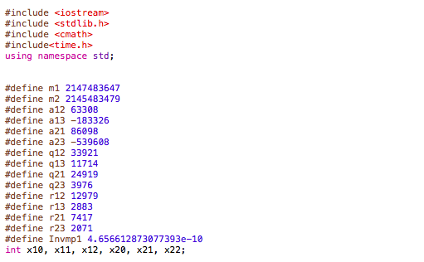

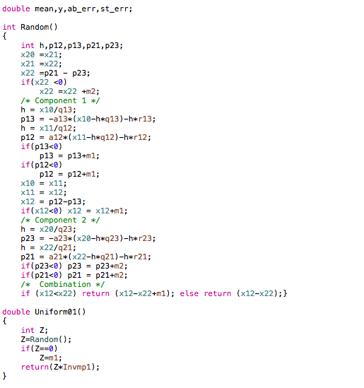

the output:

|  |  |  |  |  |
| --- | --- | --- | --- | --- |
| Sample size | estimate | Abs error | Std error | Time |
| 100 | 0.438006 | 0.0619941 | 0.0290839 | 9.3e-05 second |
| 1000 | 0.473855 | 0.0261448 | 0.00914913 | 0.000183 second |
| 5000 | 0.502204 | 0.00220437 | 0.00414282 | 0.000389 second |
| 10000 | 0.499171 | 0.000828683 | 0.00287892 | 0.000728 second |
| 50000 | 0.500463 | 0.000463417 | 0.00129324 | 0.003426 second |
| 200000 | 0.498852 | 0.00114816 | 0.000645808 | 0.015489 second |

Get uniform

|  |  |  |  |  |
| --- | --- | --- | --- | --- |
| Sample size | estimate | Abs error | Std error | Time |
| 100 | 0.546825 | 0.0468248 | 0.0285322 | 6.9e-05 second |
| 1000 | 0.508125 | 0.00812547 | 0.00898007 | 9.3e-05 second |
| 5000 | 0.499101 | 0.000898994 | 0.00408206 | 0.000229 second |
| 10,000 | 0.497132 | 0.00286778 | 0.0028828 | 0.000346 second |
| 50,000 | 0.498402 | 0.00159766 | 0.00129121 | 0.001454 second |
| 200000 | 0.499864 | 0.000135772 | 0.000644657 | 0.005733 second |

2.

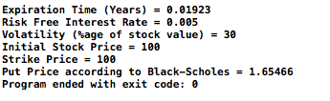

3.

Box Muller:

|  |  |  |  |  |
| --- | --- | --- | --- | --- |
| Sample size | estimate | Abs error | Std error | Time |
| 500 | 1.64442 | 0.0102428 | 0.109913 | 0.0001 second |
| 3,000 | 1.7005 | 0.0458412 | 0.0460321 | 0.000652 second |
| 30,000 | 1.66548 | 0.0108187 | 0.0143056 | 0.005976 second |
| 300,000 | 1.65947 | 0.00480941 | 0.0045467 | 0.058723 second |
| 3,000,000 | 1.66075 | 0.00609184 | 0.00143716 | 0.662582 second |
| 30,000,000 | 1.66488 | 0.0102162 | 0.000455106 | 6.10378 seconds |

Inverse transform :

|  |  |  |  |  |
| --- | --- | --- | --- | --- |
| Sample size | estimate | Abs error | Std error | Time |
| 500 | 1.56014 | 0.094516 | 0.105079 | 0.000334 second |
| 3,000 | 1.66302 | 0.00836341 | 0.0461253 | 0.001898 second |
| 30,000 | 1.64274 | 0.0119223 | 0.0142847 | 0.018238 second |
| 300,000 | 1.65917 | 0.00451042 | 0.00454467 | 0.192417 second |
| 3,000,000 | 1.66564 | 0.0109821 | 0.00144016 | 1.88785 seconds |
| 30,000,000 | 1.66435 | 0.00969301 | 0.000455073 | 19.1077 seconds |

Acceptance rejection

|  |  |  |  |  |
| --- | --- | --- | --- | --- |
| Sample size | estimate | Abs error | Std error | Time |
| 500 | 1.70127 | 0.0466128 | 0.106682 | 0.000283 second |
| 3,000 | 1.68525 | 0.0305926 | 0.0452175 | 0.000866 second |
| 30,000 | 1.67001 | 0.0153494 | 0.0143759 | 0.007189 second |
| 300,000 | 1.66354 | 0.00887973 | 0.0045513 | 0.075029 second |
| 3,000,000 | 1.66287 | 0.00820522 | 0.00143726 | 0.776163 second |
| 30,000,000 | 1.66435 | 0.00968893 | 0.000454834 | 7.33676 seconds |

Box Muller is the most efficient. For the same sample size, three methods have relative the same standard error, but box Muller has less computation time